**Converting extensive-form games to normal-form**

Homework #4

1) *Convert the following extensive-form game to a normal-form game. My payoffs are given first, followed by those of my kids. Identify, all pure-strategy Nash equilibrium, and indicate which Nash equilibrium are sub-game perfect. Indicate how you would play the game if you were “Me” and my “Kids,” respectively.*

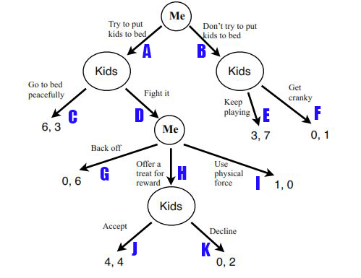

Me { AG, AH, AI, BG, BH, BI }

Kids {CEJ, CEK, CFJ, CFK, DEJ, DEK, DFJ, DFK}

|  |  |  |  |  |  |  |
| --- | --- | --- | --- | --- | --- | --- |
|  | AG | AH | AI | BG | BH | BI |
| CEJ | 3,6 | 3,6 | 3,6 | 7,3 | 7,3 | 7,3 |
| CEK | 3,6 | 3,6 | 3,6 | 7,3 | 7,3 | 7,3 |
| CFJ | 3,6 | 3,6 | 3,6 | 1,0 | 1,0 | 1,0 |
| CFK | 3,6 | 3,6 | 3,6 | 1,0 | 1,0 | 1,0 |
| DEJ | 6,0 | 4,4 * | 0,1 | 7,3 | 7,3 | 7,3 |
| DEK | 6,0 | 2,0 | 0,1 | 7,3 | 7,3 | 7,3 |
| DFJ | 6,0 | 4,4 | 0,1 | 1,0 | 1,0 | 1,0 |
| DFK | 6,0 | 2,0 | 0,1 | 1,0 | 1,0 | 1,0 |

There are 9 pure strategy Nash equilibriums in this game, which are highlighted in yellow in the table above. By going through and inspecting each Nash equilibrium, we’ll find out that sub-game perfection for this game is {DEJ, AH} joint action, which is marked with asterisk in the table above.

If I were You, I would play action “A” at the first turn, because playing “B” will give me a payoff of either 3 or 0, which is not so beneficial for me. On the second turn, the Kids will most likely play action “D”, otherwise their payoff will not be so high. On the third turn I would do my best to convince the Kids that if they play action “J” on the next turn, I would play action “H” on this turn, otherwise I would play action “I”, which is completely unprofitable for them. Moreover, taking into account that the Kids are rational, on the next turn they will choose action “J” because their payoff will be higher in that case. Considering these two facts, I would play action “H”. Hopefully, on the next turn the Kids will play action “J” ☺ To sum up, playing action “A” on the first turn is more profitable for me and most likely I will get a payoff of either 6 or 4.

Let’s consider the case when I were Your Kids. The most convenient case for me would be if you play “B” on the first turn, as I will get a payoff of either 7 or 1. However, if you play “A”, I will play “D” on the second turn, considering that you are rational and won’t choose “I” on the next turn, because you can get higher payoff playing other actions. If you play “G” on the third turn, I will get a payoff of 6, which is pretty good☺, however, taking into account that you are rational and will choose actions that give you a higher payoff, most likely you will play “H”. Accordingly, on the 4-th turn I will play “J”, which gives me a payoff of 4. In conclusion, I will get the highest payoff if you play “B” on the first turn, anyway, most likely you won’t play that action because it is less profitable for you than “A”. So, if you play “A” on the first turn, then most likely I will get a payoff of 6, 4 or 2.

2) *In a page or less, argue why or why not an agent should consider using mixed strategies in one-shot matrix games and repeated matrix games.*

When it comes to one-shot matrix games, I strongly disagree with the assumption to play mixed strategies.

Let’s consider 2 x 2 matrix game. Unlike a pure strategy, which guarantees you an exact payoff if you play a certain action with a probability of 1, a mixed strategy assumes that if you choose an action P * T times (where P is the given probability and T is the number of times game is repeated and P doesn’t equal to 1 or 0) and the other action (1-P) * T times, you will get some constant payoff. Therefore, playing mixed strategy in a one-shot matrix game will not guarantee you an exact payoff, instead, you will get a random payoff depending on your opponent’s choice. However, sometimes mixed strategies are effective in repeated matrix games. For example, in a matrix game you might find a mixed strategy which gives you a higher payoff rather than a pure strategy. All in all, pure strategies are more effective in one-shot matrix games and mixed strategies in repeated ones.